Parent Handbook
Drop Off Time | 08:50
Pick Up Time | 15:15

We look forward to welcoming your child back into school – this is important information about coming back to school safely, please read it carefully. The best bits about our school are still the same, but because of Coronavirus we continue to adapt how we do things.
The 7 C’s
Our values underpin everything we do at George Dixon Primary School. They determine how we approach our learning and interact with others. We believe that the 7C’s make our school a better place to be, alongside the British Values of democracy, individual liberty, tolerance, mutual respect and the rule of law.
CONSIDERATION CARE COURTESY COURAGE
COMMITMENT CO-OPERATION COMMUNICATION

Our School Rules
We care for ourselves, each other, and our things.
We do our best because we are committed to our learning.
We listen to the adults and cooperate with each other.
We are courteous; we smile and use our manners.
We think about the needs of others and act in a considerate way.
We show courage by aiming high and taking risks in our learning.
We communicate with each other and know it is important to talk about our thoughts and feelings.

Safe Reopening

So that we can keep all pupils and staff safe we have taken put the following essential measures in place,

- a requirement that people who are ill with symptoms of COVID-19 stay at home and inform the school if this is the case (all absences must be reported to the school before 10am please)
- robust hand and respiratory hygiene
- enhanced cleaning arrangements
- active engagement with NHS Test and Trace
- formal consideration of how to reduce contacts and maximise distancing between those in school wherever possible and minimise potential for contamination so far as is reasonably practicable

The Department for Education has said that the use of PPE is not necessary on a routine, day-to-day basis in schools. However, staff have been trained to use PPE if they need to provide care for a child who does develop symptoms.
Attendance
It is your parental responsibility to ensure your child attends school every day. If they are unwell or cannot attend for any reason you must let the school know by phoning 0121 675 2775 by 8.45am each day that they are absent.

The School Day
We aim to teach our full curriculum and delivering a broad and balanced education remains our top priority.
Children will wash their hands frequently, and we will operate a rigorous ‘catch it, bin it, kill it’ approach to respiratory hygiene. We have stocked up on soap, hand-sanitiser, tissues and lidded bins. Rooms and equipment will be cleaned regularly.
We warmly welcome communication with parents and families; however, we cannot do this at the classroom door due to physical distancing requirements and the challenges of staggered start and end times. If you would like to speak to your child’s teacher, please wait to speak to them until all other parents have gone at the end of the day remaining 2m apart at all times, or arrange a phone call or email with them using the year group email.

Uniform

We will be expecting all children to be in their normal school uniform from September onwards. Jumpers with the school logo embroidered on the front are available from the school office, and full details are available on the ‘Parents’ section of the school website.
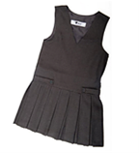
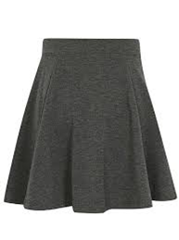
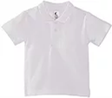
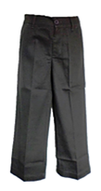
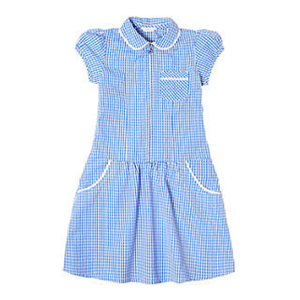
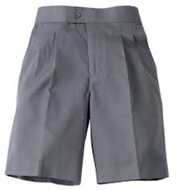

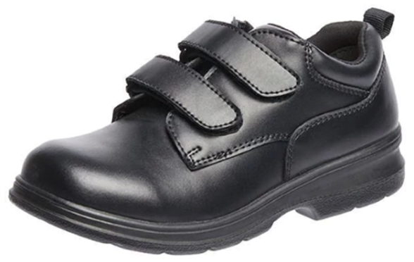
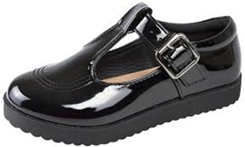

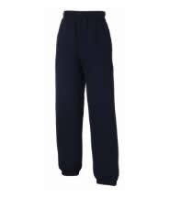
When it is your child’s day for PE do not bring PE kit in a bag, children should come to school in their PE kit in the morning. PE t-shirts with the school logo on are available from the school office at a cost of £5.15

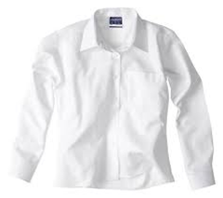
Please label EVERY item of clothing with your child’s full name
PE Days

Please see the table below for the day your child has PE and should come dressed in their PE kit.

Monday | Tuesday | Wednesday | Thursday | Friday
Year 4 | Year 5  Year 3 | Year 6  Year 1 | Reception | Year 2

Lunches& Snacks

You can pay for a school dinner for your child using SQuid (details available from the front office). Parents are of course welcome to send children in with a packed lunch of their own if they prefer but these packed lunches must be brought in at the start of the day by the children and must be a healthy lunch with a ‘main’ lunch (sandwich, noodles or rice type of dish) with fruit, vegetables and yogurt too if you wish. Chocolate and crisps should only be sent in on a Friday.

Although children in Reception, Year 1 and Year 2 receive a universal free school meal your child may be eligible for free school meals too. So whatever year your child is in fill in the pupil premium eligibility checker online, from the office. (The school receives additional funding to support your child if they are eligible for pupil premium funding and they will receive a free school meal or voucher if the school closes due to Coronavirus.)

Healthy snacks (fruit, vegetable or granola bars) may be brought in to have at break times.

Dropping Off & Picking Up

To keep everybody as safe as possible we will maintain our one way systems around the school. We continue to ask that only one adult per household attends the school to drop off or pick up children and please maintain your distance from other families while you are on site and wear a mask if you wish.
During morning drop off, parents and children will enter through the front gate; children will then enter independently through the Reception, KS1 or KS2 gate; parents will leave through the carpark gate - see the pictures below for more details.
In the afternoons, parents will be asked to follow the one-way system around the school building and pickup their child(ren) from classrooms as they go, again see pictures below. Please line up one behind the other outside the classroom windows to collect your child. This will free up space for families to walk around the building.
Unless your family has a disability badge and you have made an arrangement with the school please do not use the staff car park.

Medicine in School

If your child has been prescribed medicine and must take it during school hours, please let the school office know as there is a form that you must fill in before we can do this.
One Way System For Drop Off
Reception Entrance

Entrance for Year 1, Year 2, Year 3 and Year 4
Entrance for Year 5 & Year 6

Parent Exit

Entrance

If you are early, there will be marked stars to show physical distancing measures in the front courtyard – please keep 2m apart.
One Way System for Pick Up
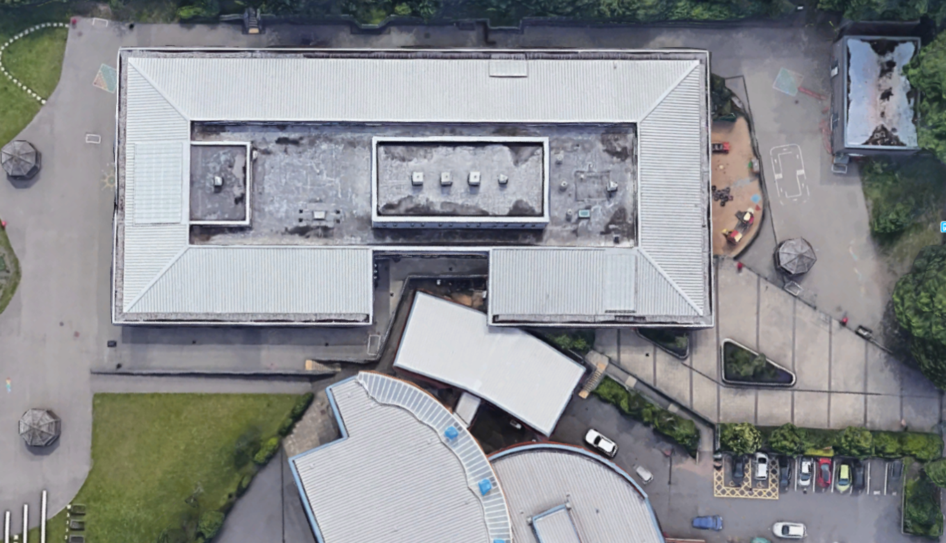
Parent Exit
Parent Entrance
Children can no longer be collected late from the main office due to physical distancing; you may be charged for childcare after
3.30pm.
Mrs P Kaur
Ms Morgan
Mrs Reehal
Mrs Sidhu
Mrs Mankoo

Signs, Symptoms And Suspected Cases

From September school attendance will be compulsory, however: if you, your child(ren) or anyone in your household shows any of the symptoms of COVID-19 do not send your child to school – the whole family should self-isolate for 10 days and seek a test to confirm whether it is COVID-19 or not.

The main symptoms of coronavirus are:
- high temperature – this means you feel hot to touch on your chest or back (you do not need to measure your temperature)
- new, continuous cough – this means coughing a lot for more than an hour, or 3 or more coughing episodes in 24 hours (if you usually have a cough, it may be worse than usual)
- loss or change to your sense of smell or taste – this means you've noticed you cannot smell or taste anything, or things smell or taste different to normal

Most people with coronavirus have at least one of these symptoms.
If a child displays symptoms of COVID-19 during the school day, we will contact parents to come and collect them immediately to go and get a COVID-19 test. If a child returns a positive test their in-school bubble will self-isolate for 14 days and their area of the school will be deep cleaned. If a symptomatic child’s test is negative, they will remain at home until they are well again from whatever illness they did have.

Before & After School Club

There will be a breakfast club available from 8:30 in the Arts and Sciences Area; we will ask for a voluntary contribution of £1 per week per child.

There will be paid for after school club from 3:30 till 4:30 for the children of key workers (please see the school office if you wish your child to be considered and you are not a key worker), and this will need to be booked via SQuid – see the office for pricing.

We also hope to start our After School Clubs again in the Autumn Term and will send you further information in due course.

Swimming

Year 5 classes will have Swimming Lessons from September – February and Year 4 from February – July. Further information will be shared with families in due course.

